Workbook Companion to
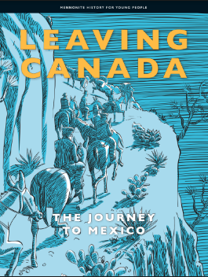
This workbook is meant as a companion piece to the text, Mennonite History for Young People Volume 1 - Leaving Canada: The Journey to Mexico. By using a culturally relevant text with our Mennonite students it is hoped that the learners will be more engaged as they see themselves and their culture as respected and valued, reflected within both the historical context and today.
The intent of this workbook is to connect with the Ontario curriculum for Language Arts and Social Studies. The Mennonite History books, and by extension this workbook, meet the goals of social studies as described in the introduction of the Ontario Social Studies Curriculum by helping learners to develop a sense of self, time and place. The questions within connect with the strands of the grades 1-6 Social Studies Curriculum of A. Heritage and Identity and B. People and Environments as well as the grade 7 Geography strand Natural Resources Around the World and the grade 8 History strand Creating Canada and Geography strand Global Settlement. The text also connects wonderfully to the Language Arts Curriculum as it is presented using a range of text forms (diary entries, vignettes, informational text and graphics) and provides opportunities for vocabulary development within a supported context. Because the text is written at a grade 6 reading level, the specific expectations covered in the grade 6 Social Studies and Language Arts Curriculum can be found on page 2.
The skills developed within this workbook include:
- Using contextual clues to identify the meaning of new words
- Using text features to further understanding
- Using graphic organizers to develop ideas and sort information
- Evaluating primary resources to develop a more thorough understanding of historical events and experiences
- Looking at different points of view
- Retelling and summarizing
- Reading and understanding maps
- Framing their own knowledge, experience and culture within a historical context

Curricular Connections
Ontario Social Studies Curriculum
A1.1 explain how various features that characterize a community can contribute to the identity and image of a country
A1.2 evaluate some of the contributions that various ethnic and/or religious groups have made to Canadian identity
A2.2 gather and organize information from a variety of primary and secondary sources using various technologies
A2.3 analyse and construct print and digital maps as part of their investigations into different perspectives on the historical and/or contemporary experience of communities in Canada
A2.4 interpret and analyse information and evidence relevant to their investigations, using a variety of tools
A3.1 identify the main reasons why different peoples came to Canada
A3.3 identify various types of communities that have contributed to the development of Canada
A3.7 describe significant changes within their own community in Canada
Language Arts Reading
1.1 read a wide variety of texts from diverse cultures, including literary texts
1.3 identify a variety of reading comprehension strategies and use them appropriately before, during, and after reading to understand increasingly complex texts
1.4 demonstrate understanding of increasingly complex texts by summarizing and explaining important ideas and citing relevant supporting details
1.5 develop interpretations about texts using stated and implied ideas to support their interpretations
1.8 make judgements and draw conclusions about ideas in texts and cite stated or implied evidence from the text to support their views
2.3 identify a variety of text features and explain how they help readers understand texts
3.2 predict the meaning of and rapidly solve unfamiliar words using different types of cues
Language Arts Writing
1.5 identify and order main ideas and supporting details and group them into units that could be used to develop a structured, multi-paragraph piece of writing, using a variety of strategies
2.1 write longer and more complex texts using a wide range of forms
Graphic organizers were adapted from https://teachertools.studiesweekly.com/graphic-organizers/ and made using Canva.
Chapter One: Before You Read the Story
This first chapter builds the background knowledge you need to understand the stories that follow. To record our ideas and summarize our learning we are going to use a K-W-L chart. Before you start reading, write down as much as you can of what you already know about how the Mennonites left Canada in the K-column. Then write any questions you have, or what you want to know more about in the W-column. As you read, you can fill in facts that you learn in the L-column. An example is given to help you understand what to do.
K-W-L Chart
K  What I know | W  What I want to learn | L  What I learned
Mennonites are Christians. | Why did Mennonites pick Mexico? | Mexico gave the Mennonites a Privilegium.

Vocabulary Building
Reading is one of the best ways to learn new words. When we find new words in text, it can be helpful to guess their meaning from the context, or the other words, of the sentence. In this text the meaning of the bolded words can often be found by looking at the context clues right after it. If you are still not sure what the word means, you can use the glossary in the back of the text (starting on page 80). A glossary has key words listed in alphabetical order with their definitions. Complete this chart of important vocabulary as you read the text. The first line is completed for you.
Word | I know this word./This is a new word for me. | How it appears in the text | What I think the word means
founded | This is a new word for me. | “As more Mennonites arrived in Russia, they founded, started their own colonies.” (pg. 1) | started
reorganized |  | “In Mexico they reorganized, renamed their church, and called it the Old Colony Mennonite Church.” (pg. 2)
tract |  | “A colony in Mexico was a large tract, an area of land, divided into villages.” (pg. 2)
elected |  | “The colonists elected, chose, two groups of leaders…” (pg. 3)
civil |  | “The colonists elected, chose, two groups of leaders: one for the church and one for civil, everyday life on the colony.” (pg. 3)
demonstrate |  | “Their rule for living was that their everyday life must demonstrate, show, their Christian faith.” (pg. 5)
humble |  | “Life was simple and humble, not proud.” (pg. 5)
chartered |  | “The Manitoba Mennonites chartered thirty-six trains for their move.” (pg. 7)
crops |  | “As soon as possible, plant crops such as corn or wheat.” (pg. 8)
unity |  | “Unity, living together peacefully, was important.” (pg. 9)

Pick 3 words that were new to you and write a sentence using the word to show your understanding of the word’s meaning.

History is being written all the time. You and your family are a big part of history as well. Talk with your family to answer the following questions.
- Where do you live?

- When did members of your community first come here?

- Where did they come from before that?

- Has your community experienced discrimination (been treated unfairly) in Canada?

Think about your answers as you read this text. It will help you to make connections to what you are reading and develop an understanding of your family and community’s place in history.
Chapter Two: Departure
Vocabulary Building
Complete this chart of important vocabulary as you read this chapter.
Word | I know this word./This is a new word for me. | How it appears in the text | What I think the word means
public |  | “If parents stayed in Canada, their children would have to go to public, government schools.” (pg. 15)
delegates |  | “Those men were their delegates. They did their work…for, the people.” (pg. 16)
on behalf of |  | “They did their work on behalf of, for, the people.” (pg. 16)
abysses |  | “Now we could see how dangerous the cliffs, and how deep the abysses, the gorges, were.” (pg. 21)
minister of agriculture |  | “We had already met the minister of agriculture.” (pg. 21)
agitated |  | “Everyday they came home with empty stomachs and agitated, troubled minds.” (pg. 24)
inherited |  | “She had inherited, got it, from Lena’s grandparents.” (pg. 25)
tirade |  | “And so ended their tirade, their outburst.” (pg. 25)
put down the cash |  | “The interested buyer put down the cash, paid.” (pg. 29)
autobiography |  | “Later in his life, Ohm Iezak wrote his autobiography, his life story.” (pg. 30)
hugely complicated |  | “We asked God for his presence and protection in the hugely complicated, very difficult journey.” (pg. 31-32)
out of sight |  | “The train passed first one village, then another and another until all were out of sight, gone.” (pg. 32)
terrified |  | “Many were terrified, very afraid especially as darkness fell.” (pg. 35)
shrieking |  | “The train raced with a shrieking, loud roaring, into the dark night.” (pg. 35)
jostling |  | “They were afraid for their cattle, jostling, being pushed around in the cattle cars.” (pg. 35)

Pick 3 words or phrases that were new to you and write a sentence using the word to show your understanding of the word’s meaning.

Comprehension Questions
This chapter begins with a quote from Ohm Iezak (Minister Isaak Dyck), “Life is a walking stick.” Ohm Iezak was thinking of four things when he said this:
- Hebrews in the Old Testament walking for 40 years to freedom.
- Menno Simons being forced to always move so he would not be killed for his faith.
- The first Mennonite settlers to Manitoba, Canada from Russia.
- His community moving to Mexico.

- Pick one of the four things he was thinking of and explain how it connects to the quote.

- How do you connect with this quote? Write 3 sentences about a time in your life where you felt that “Life is a walking stick.”

- A push factor is a reason, be it social (related to people and community), political (related to government), economic (related to money), or environmental (related to the environment) that makes people leave the place they live for somewhere new. What were some of the push factors that made Mennonites want to leave Canada? Fill in your answers in the Cause and Effect organizer below (the situation and effects are filled in for you to give an idea of how the organizer works).
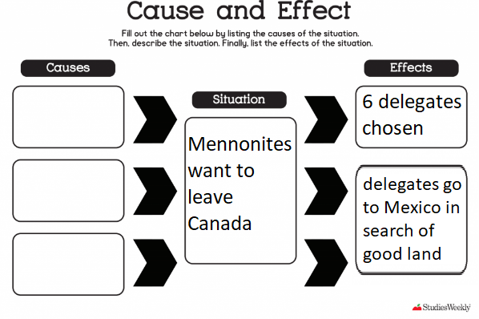

- A pull factor is a reason, be it social, political, economic, or environmental that makes a new place an attractive choice for people leaving their homes. What were some of the pull factors that made Mexico a good choice for Mennonites? Fill in your answers in the Cause and Effect organizer below.
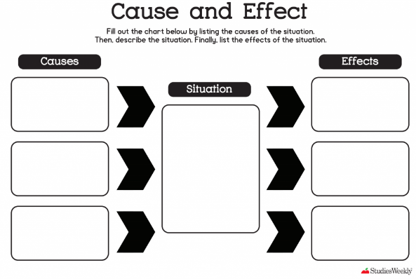
- Primary resources, texts written by people at the time of an event, are incredibly valuable in learning about history. We are very lucky that delegate David Rempel kept a diary of his journey as it gives us meaningful insight into how the delegates were feeling and what the experience was like. Find 3 quotes from Rempel’s diary that best show what the journey was like. Write the quotes below. Remember to use quotation marks around the quote and to cite the page number for easy reference.

- For the next 3 questions, you will be reading the map on page 18.
  - Where did the delegates start their journey?

  - Where did they finish?

  - What do you notice about the route the delegates took? Write 3 sentences that describe the journey the delegates took as illustrated by the map on page 18.

- The delegates and the Mexican president signed a Privilegium. What were the promises Mexico made to the Mennonites?

- Why was it important that the Mennonites get a Privilegium before buying land in Mexico?

- After the land in Mexico was bought, the next step was to sell the land in Canada. This proved to be very difficult. Identify (write) 2 reasons why the plan to sell the land in Manitoba, while a good plan, did not work.

- The Mennonite rule for inheritance, the Waisenordnung, was quite unique and forward-thinking in Canada at the time. In the early 1900s Canada’s laws of inheritance still mostly denied women property with most of an inheritance going to the eldest son. How does Waisenordnung work and why is it a better system of inheritance?

Chapter Three: Arrival
Vocabulary Building
Complete this chart of important vocabulary as you read this chapter.
Word | I know this word./This is a new word for me. | How it appears in the text | What I think the word means
boarded |  | “Just then twenty soldiers carrying rifles boarded, got on the train.” (pg. 38)
dilapidated |  | “The town we had come to had only a train station, a couple of broken down houses, and the dilapidated, rundown Immigration House.” (pg. 42)
cajoled |  | “She played with them, put them to sleep when they were tired, cajoled, sweet-talked them when they were being fussy.” (pg. 49)
optimists |  | “Anna’s parents were such optimists, always seeing the bright side.” (pg. 49)
collapse |  | “It seemed the bar would break and everything would collapse, fall down.” (pg. 50)

Pick 3 words that were new to you and write a sentence using the word to show your understanding of the word’s meaning.

Comprehension Questions
- When the train carrying the Mennonites reached the border between the United States of America and Mexico some differences became obvious (clear, could easily be seen and noticed). Complete the Venn diagram comparing and contrasting (showing some similarities and differences) between Canada and Mexico. In the part of the diagram that says Canada, write things that are true only of Canada. In the part of the diagram that says Mexico, write things that are true only of Mexico. In the space that overlaps between the two circles write things that were true of both places. (Hint: think about what the environment was like; What could they see, what did they hear?) Some examples are given for each to help you. As you read more chapters, you can come back to this diagram and add more information.
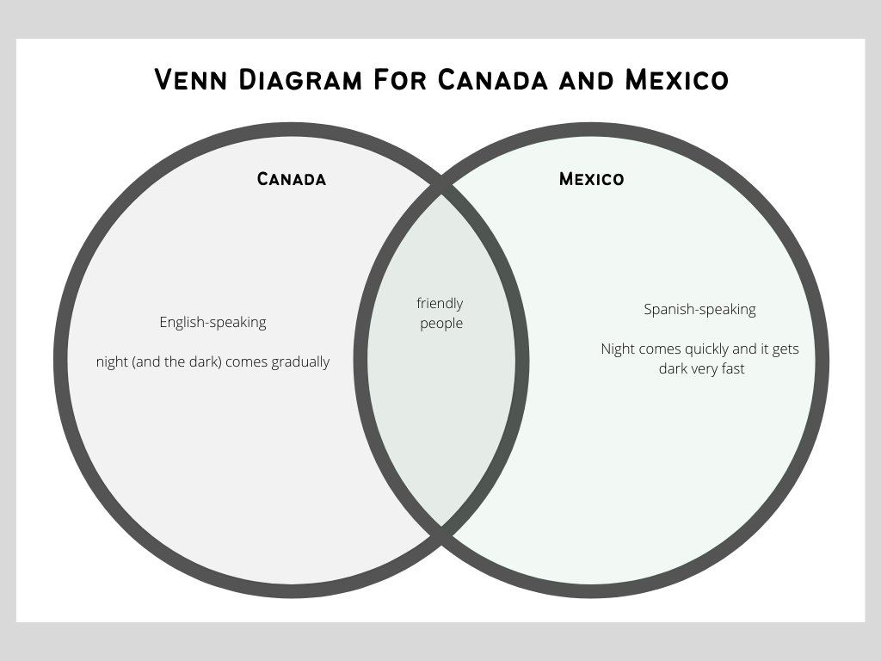
- When did Mennonites first arrive in Mexico?

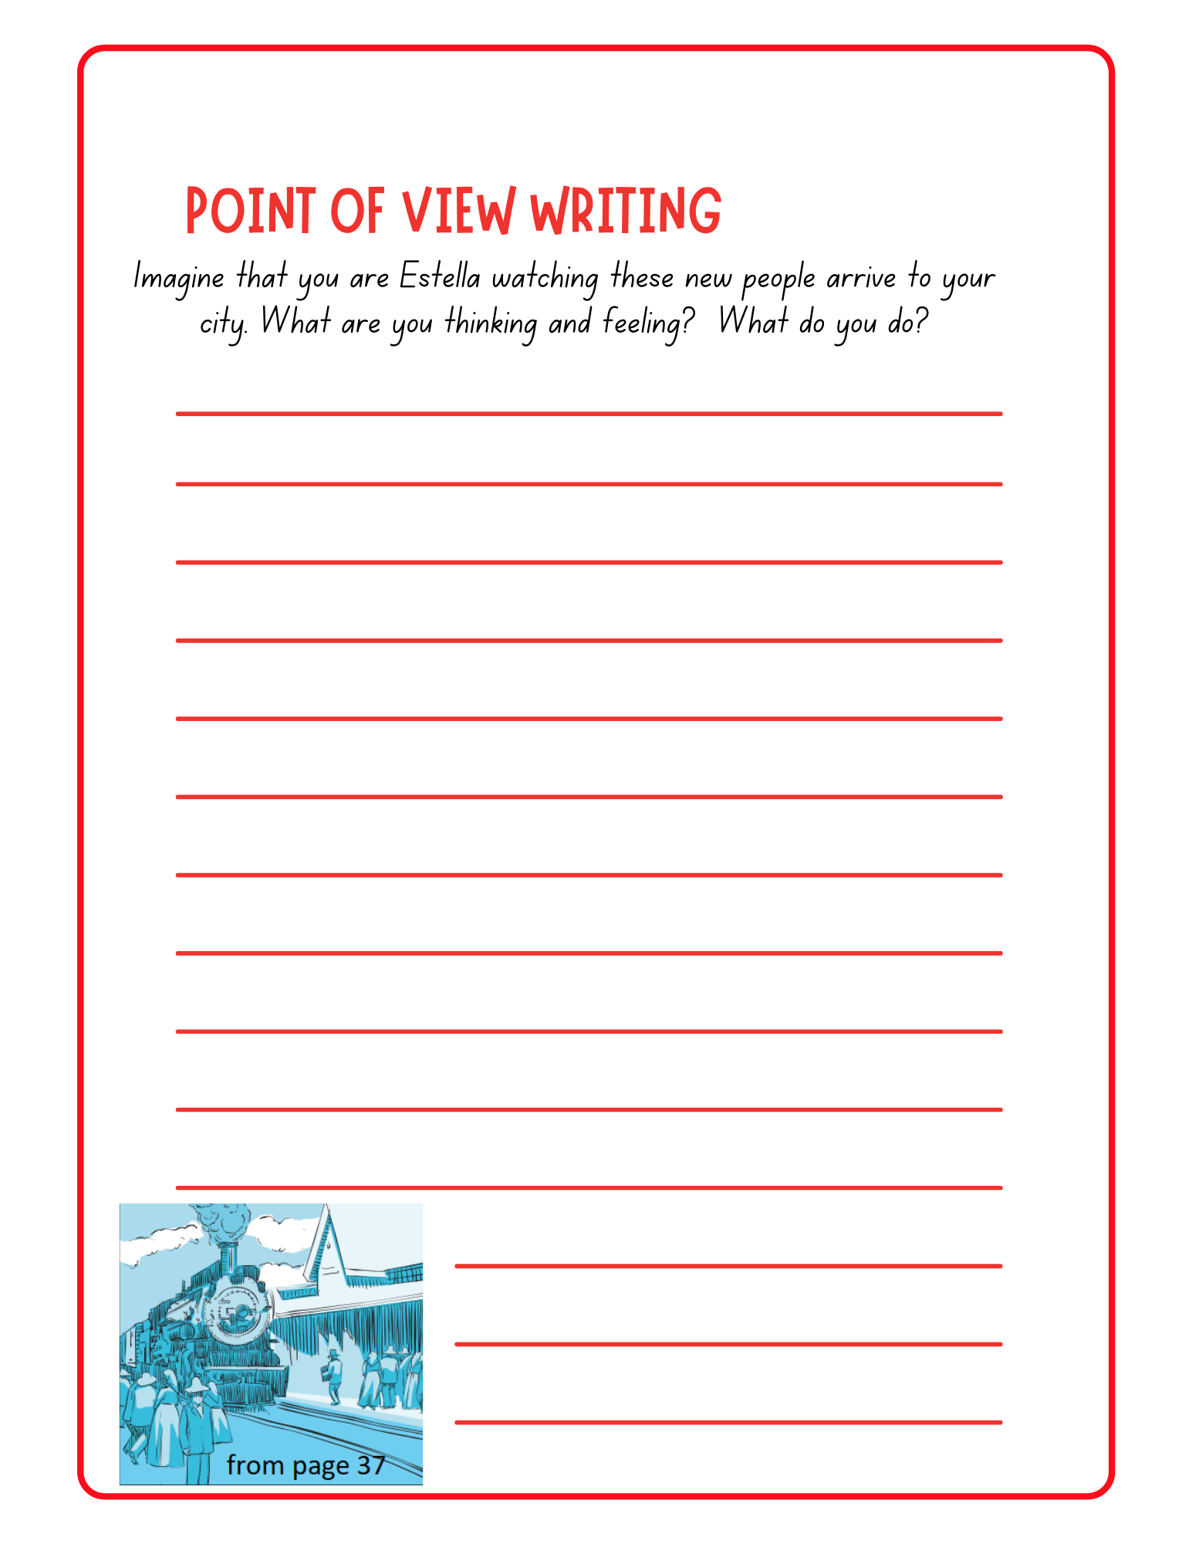
- The vignette on page 43 is a glimpse into what the experience was like for a young girl, Sarah, arriving in San Antonio de los Arenales with her family. The writer describes how Sarah is feeling, “Her dress felt hot and sticky” and how she spots a girl “about her age, with brown skin and black hair, watching her” (page 43). The vignette then flips and we see Sarah from the other girl’s (Estella’s) point of view. “Estella saw a white-skinned girl… wearing a large white kerchief decorated with colourful flowers… a long dress. Estela smiled at the girl. Sarah smiled back.”
Write a short story continuing the vignette from Estella’s point of view. Think about what Estella might have felt and seen that day as the Mennonites arrived in her hometown.

- People often say that a picture is worth a thousand words, by which they mean we can learn a lot from looking at pictures. Look at the picture on page 45. What do you see? What is happening in this picture? (Hint: underneath a picture in a text is a caption. A caption is a short explanation of what is happening in the picture. You can use the caption to help you with your answer if you need it.)

Chapter 4: First Things First
Vocabulary Building
Complete this chart of important vocabulary as you read this chapter.
Word | I know this word./This is a new word for me. | How it appears in the text | What I think the word means
necessities of life |  | “They had to make sure they had the three necessities of life: shelter, water and food.” (pg. 53)
urgent |  | “Finding water was urgent, very important.” (pg. 54)
arid climate |  | “Chihuahua had an arid climate, dry weather.” (pg. 54)

Pick 1 of the words or phrases that was new to you and write a sentence using the word/phrase to show your understanding of its meaning.

Comprehension Questions
- This chapter talks about the three necessities of life (things needed to live): shelter, water and food. First, the Mennonites set up shelter with the tents they had brought. Next, they dug wells for water and finally they figured out food. Fill in the concept patterns chart on the next page to show your understanding of why each of these three things was so important for the Mennonites as they settled in Mexico. The topic and categories have already been filled in for you.

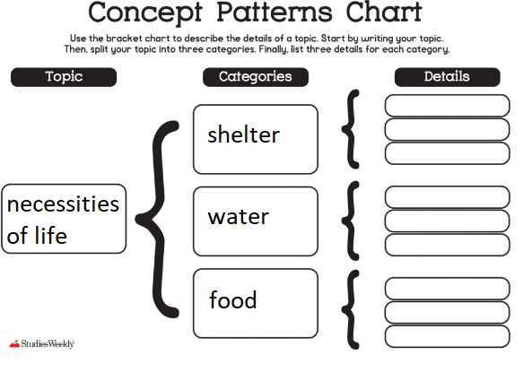
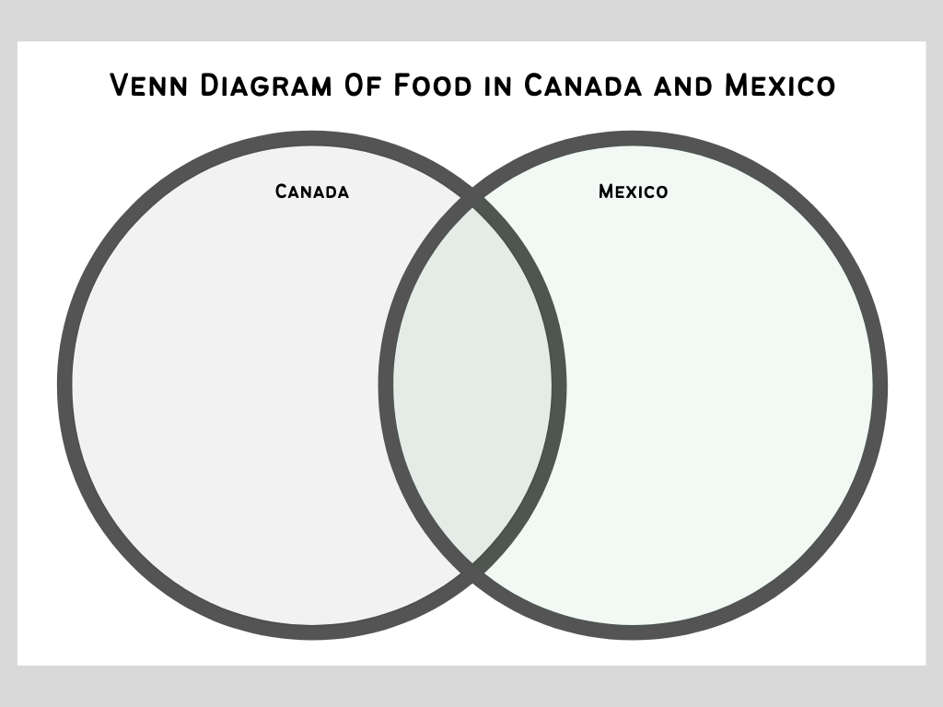
- This chapter talks about how some food was the same and some different between Canada and Mexico. Some things Mennonites were used to eating in Canada were not available in Mexico due to cultural differences and climate (seasonal changes and what could be farmed). Many Mennonites tried Mexican foods and enjoyed them. They are now part of their meals. Complete the Venn diagram comparing food in Mexico and Canada.

- What are some of the traditional foods your family eats? How do you think these foods are impacted (affected) by where you live?

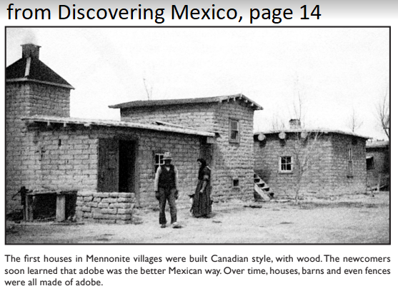
- When Mennonites first arrived in Mexico, they lived in tents they had brought with them. Then they built houses from lumber (wood). Finally, they learned how to build with adobe bricks like Mexicans do. Why might it be better to build houses from adobe bricks in Mexico? (Hint: think about the weather and what materials are most available.)

Chapter Five: Hard Times and Good Times
Vocabulary Building
Complete this chart of important vocabulary as you read this chapter.
Word | I know this word./This is a new word for me. | How it appears in the text | What I think the word means
furrows |  | “The ploughshares, newly sharpened, cut long straight furrows, rows, in rich black soil.” (pg. 60)
tremendous |  | “Father had to put tremendous, very great, pressure on the shares.” (pg. 60)
communicable disease |  | “What happens if you have a communicable disease, a sickness that spreads to others, but you don’t know how it spreads?” (pg. 62)
transparent |  | The huge desert sky felt transparent, as if you could look right through it.” (pg. 65)
creek bed |  | “Three Mexican soldiers on horses, with big revolvers sticking out of holsters at their hops, had come riding down the creek bed toward the village.” (pg. 65)
terrified |  | “Justina had been terrified, afraid.” (pg. 65)
assess the situation |  | “There he stopped to assess the situation, see where he was.” (pg. 66)
exhausted |  | “He guided his exhausted, tired horses in that direction.” (pg. 67)
sympathized |  | “Everyone sympathized, felt sorry with him.” (pg. 67)
dismounted |  | “When they arrived at the house, the two soldiers dismounted, got off their horses.” (pg. 67-68)
secure |  | “The box was supposed to be secure, safe.” (pg. 68)
punctually |  | “Letters were sent out punctually, on time from that little hit, and letters from Canada arrived safely in the simple mailbox inside.” (pg. 69)

Pick 3 words or phrases that were new to you and write a sentence using the word or phrase to show your understanding of its meaning.

Comprehension Questions
- This chapter is titled (named) Hard Times and Good Times. Is this a good title for this chapter? Why or why not?

- The first few years in Mexico were very hard for the Mennonites. Write 3-5 sentences describing what their life was like.

- What are some ways your life is different from that of the first Mennonite settlers in Mexico?

- The Mennonites that settled in Mexico were resilient (able to work through and solve difficult problems). They had learned how to farm in Canada but now needed to learn how to farm in Mexico with its very different climate (patterns of rain and temperature) and soil. They needed to learn what crops would grow in Mexico. Have you ever experienced a challenge like this before where you had to keep trying again and again before you succeeded? Write a paragraph about that time using the graphic organizer below. The topic sentence has been filled in for you. It introduces what you will be writing about in your paragraph. Next write 3 details about the time you were resilient. Then re-write the topic sentence in your own words as a concluding statement.
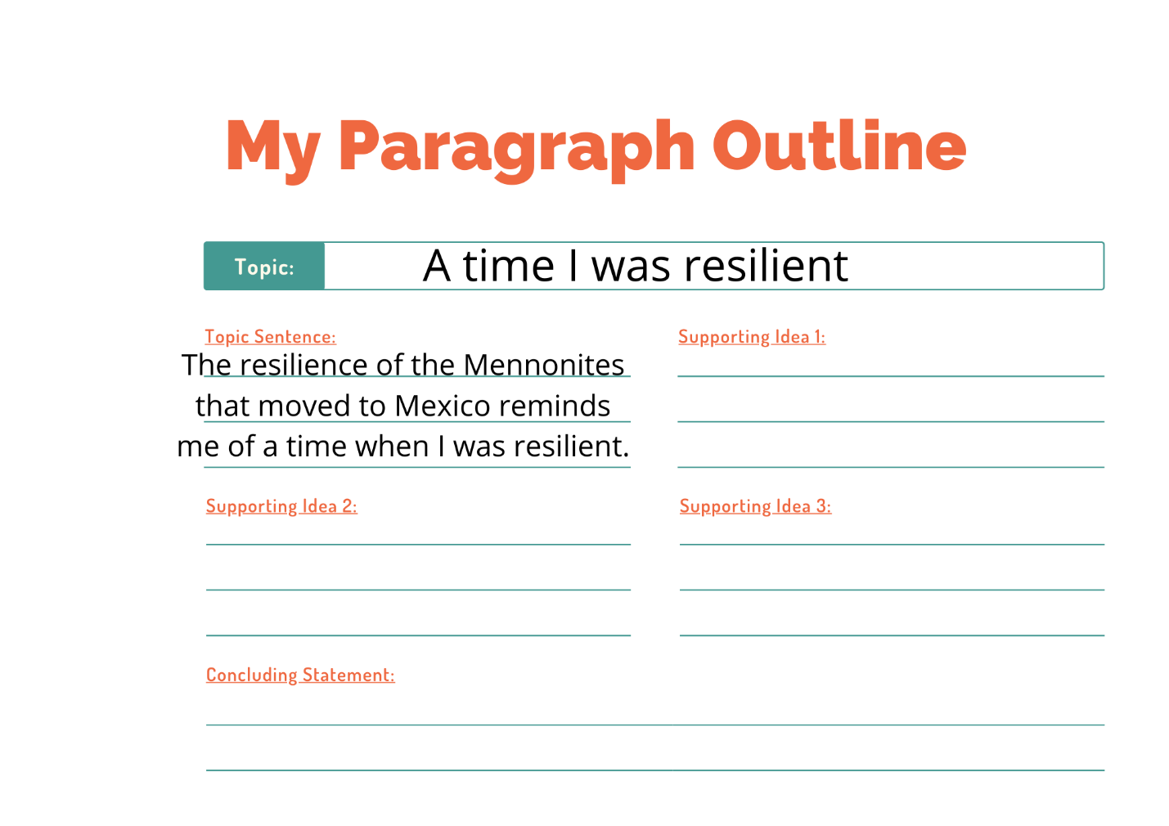
- A map is a drawing of a place that gives information about that place. It might show things that are visible there such as lakes and roads or it might show things that we can’t see in person such as borders between towns. What can we learn from looking at the map on page 70? (Hint: the small white box marked legend shows what the symbols on the map mean.)

- Letter writing was important to the Mennonite settlers in Mexico. It helped them stay connected with their friends and family in Canada. It is quite impressive how efficient the postal system was for the time with letters arriving punctually between the two places. Now that you have practiced writing a paragraph, you will try writing a letter. You may pick anyone you like to write a 3-paragraph letter to using the template on the next page. If you need help with ideas: paragraph 1 could be about how you are doing; paragraph 2 about something interesting that has happened recently; paragraph 3 any questions you have for them.
Chapter Six: The Other Two Colonies
Vocabulary Building
Complete this chart of important vocabulary as you read this chapter.
Word | I know this word./This is a new word for me. | How it appears in the text | What I think the word means
snapshots |  | “Her stories are snapshots, small pictures of life on the colony.” (pg. 74)
diligently |  | “We pretended to study diligently.”
founded |  | “The Hauge Colony was founded in 1924.” (pg. 76)

Pick 1 word that was new to you and write a sentence using the word to show your understanding of the word’s meaning.

Comprehension Questions
- This chapter includes a funny story from Sarah Wiebe where she and her friends tried to teach a lesson on the importance of punctuality (being on time). A summary is a shorter version of the story that just tells the key points. Use the graphic organizer on the next page to summarize what happened in Sarah’s Tales: A Prank (pages 75-76).

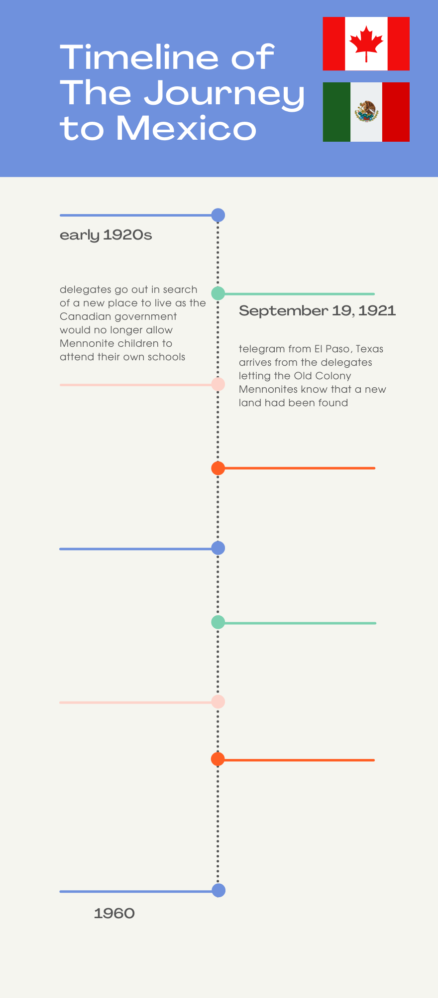
Summative Task
Now that you have read the whole text of Leaving Canada, you will create a timeline for the journey of the Mennonites from Canada to Mexico using the template. Think about all the stories you read and pick 6 key events that happened between September 19, 1921 (when the telegram arrived in Canada saying land had been found) and 1960, when the stories in our text end. You can fill the graphic organizer in using a combination of words and pictures.

